school management system

**Project Description**:

A school management system is a web-based tool that is used to manage school records such as student details and teacher details.

**Project Objectives:**

The objective of the school management system is to organize the student’s data and teachers’ data.

**Project Scope:**

In every school, there will be many numbers of students and teachers without a proper system we can not organize the data of all students and teachers which consumes more time if we want to retrieve, add, delete and search, any student and teacher.

The school management system can be used in any school based on their requirement.

**ER diagram :**

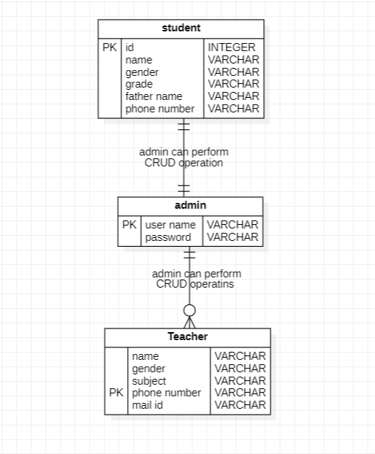

**Usecase diagram :**

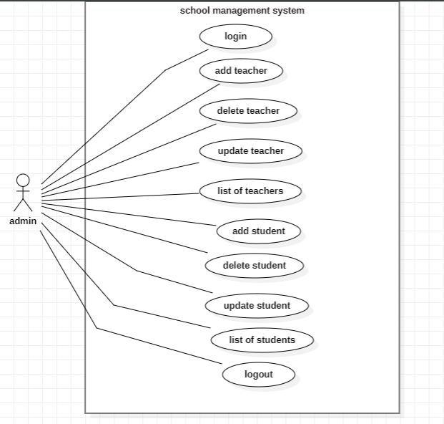

**Functional Requirements:**

**1. Admin**

* **Add students:** admin can add students along with their details and grades.
* **Delete student:** admin can delete student records by student ID if the student ID is valid.
* **Update student:** admin can update student record
* **List of students:** admin can see the list of students present in school.
* **Add Teacher:** admin can add teachers along with their details.
* **Delete teacher:** admin can delete teacher records by teacher phone number if a student-teacher phone number is valid.
* **Update teacher:** admin can update teacher record.
* **List of teachers:** admin can see list of teachers present in school.

## **Technical Requirements**

* Backend – servlets and JSP
* Front-end – HTML, CSS, Bootstrap
* Database – MYSQL
* Language – Java
* API Testing –Chrome plug-in.